Clinical Trial Questionnaire

This questionnaire shall be used only for clinical trials
to be conducted in Israel

Title of the trial:
Protocol Number
Trial inception date:
Trial end date
Trial Phase
Sponsor:
Principal investigator:
Number of Research Subjects

Date: _________________________

Company: ________________________________

Signature: ________________________________

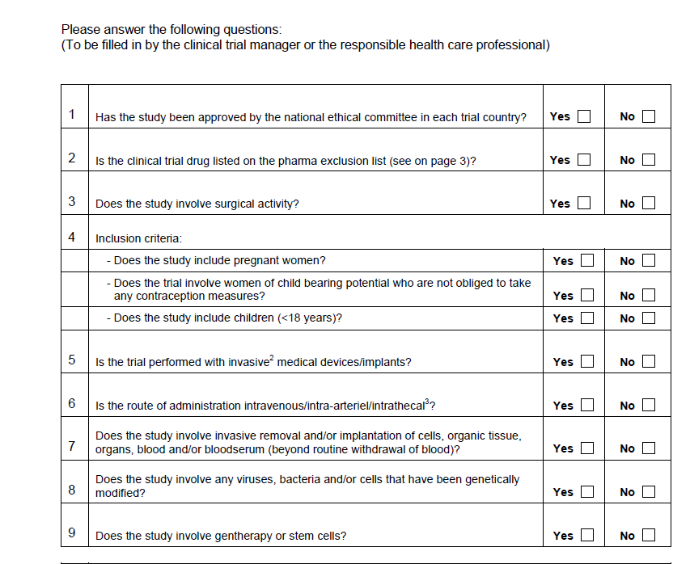
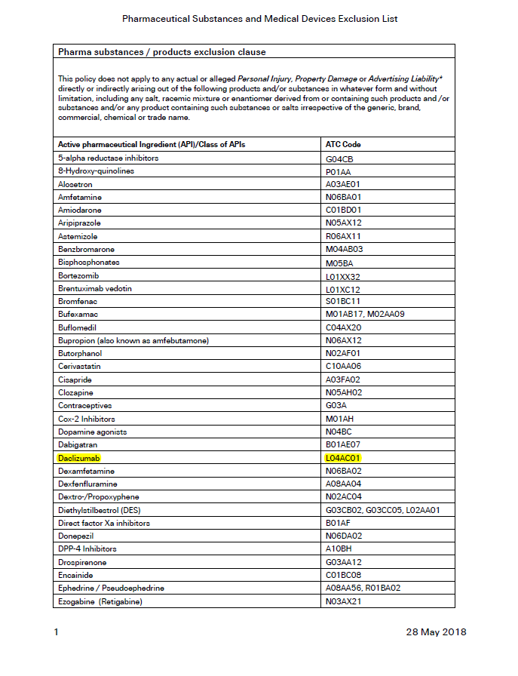
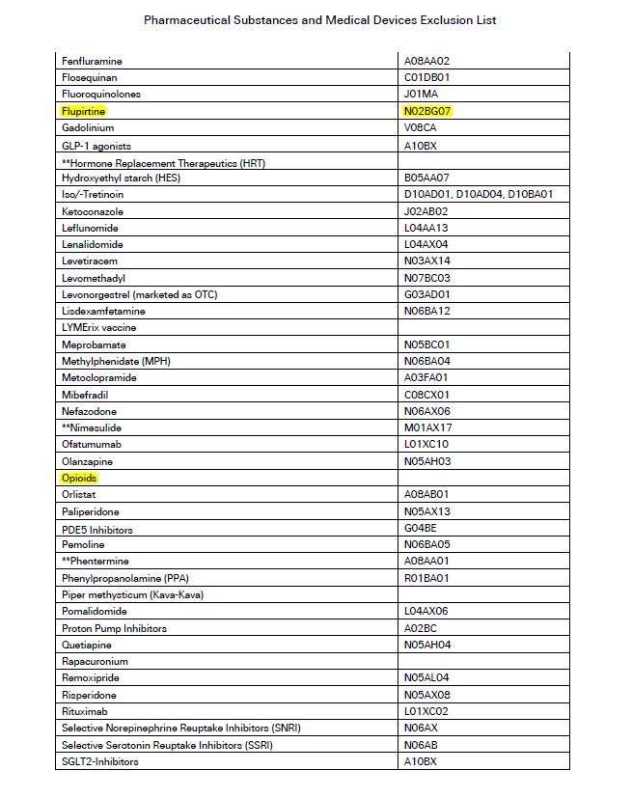
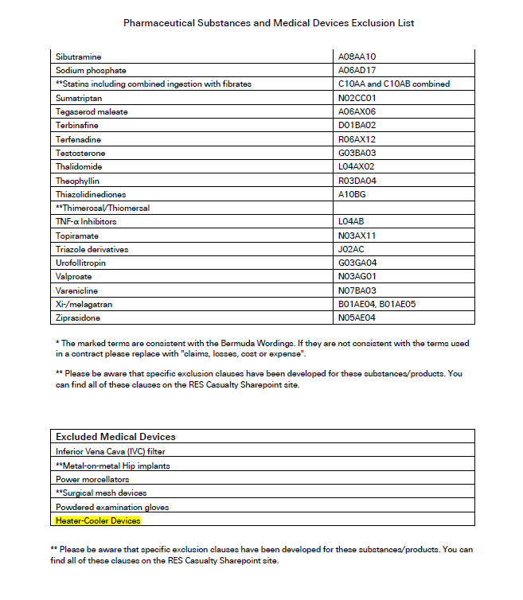

Principal investigator is the person who is responsible and directly involved in the treatment or evaluation of research subjects (e.g. Medical doctor (MD) in a hospital or general practive (GP)).

